List of Questions

If I want to add one element from the back, which method do I use?

Output based :

                        1. console.log(a);

    var a =10;

    Follow up: what will be the output if we change var to let?

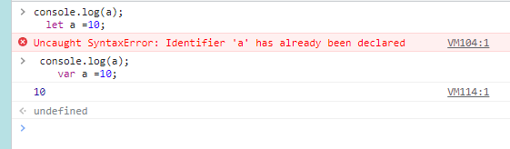

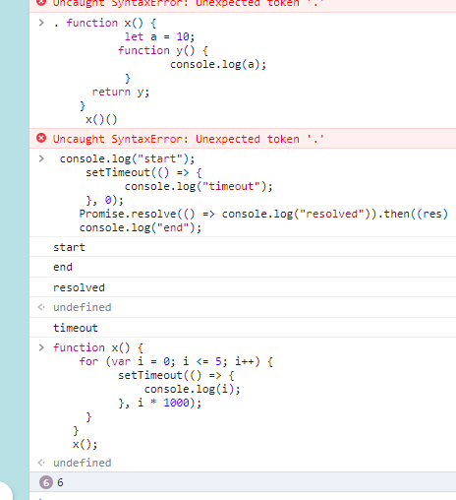

Fetch the data from the API?

Code for converting string into an array

i/p: "i like java"

o/p: ["i", "like", "java"]

write the code to find 2 max from the given array